**Soccer team layered approach**

This describes how a soccer team is formed from defense to attack to work together for a single cause: winning

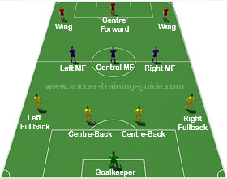

1. Goalkeeper (GK) : this is the most specialized position their only job is to guard the teams goal from being breached
2. Central Backs (CB) : their job is to stop opposition players specially central forwards from scoring , they are positioned in front of the goalkeeper
3. Full-right/left back(LB/RB) : they take up wide defensive position on the sides, their main job is to prevent opposition players from crossing or cutting the ball back into the penalty area, they are also expected to help in attacking side with crosses
4. Central/Defensive midfielder(CM/DM): they are positioned in front of the CBs and their job is to hold back the freedom of opponents to attack, and recovering the ball from enemy team
5. Attacking/Left/Right midfielder (AM/LM/RM): they serve as the offensive pivot of the team and are positioned a little bit in front of the DM, their main job is to have the intelligence to give great passes to the winger or strikers
6. Right/Left Wingers(RW/LW): they are stationed in a wide position near the touchlines and their main mission is to run along the sides and send crosses to the penalty area
7. Central Forward/Striker (CF/ST): He is the closest player to the opposite’s team goal and his main task is to score goals, he will be the one dribbling opponents to create chances to score.

An example of this layered approach would be

1. The GK stops the ball and passes it to the CBs
2. The CB passes opens the field by passing the ball to the LB/RB
3. The LB/RB runs a little bit forward and then passes to the CM/DM
4. The CM/DM gets the ball, moves around and passes to the AM/LM/RM
5. The AM/LM/RM gets the ball, looks up, and find a space to give a through pass to the LW/RW
6. The LW/RW receives the ball runs along the sideline and send a cross
7. The CF/ST receives the cross, dribbles an opponent CB and shots to goal and scores